Kevin Rodriguez

LAB 5 Report

***Introduction:***

For this lab I had to finish the class for a minHeap. I had to finish the implementation for the method ‘insert’, extract_min’. After having those implementations done, I had to come up with a function that will do heap sort using the minHeap class.

***Solution / Implementation***

The way that I did my implementation for creating a min heap is by first appending a value to a heap_array and sending the heap_array to a function that will create the array into a minheap by starting from the last element and comparing it to its parent which the formula for that is

(child – i) // 2. If the child was smaller than its parent I will swap and decreasing the index of the child by 1.

For the extracting_min method, all I did is store the value of the first index in the heap array in a variable as well as storing the value of the last index in the heap array. After that, I would remove the value of the first element and replace it with the value of the last index in the heap array and call my method that will heapify the entire array and create it again to a min_heap.

For the heap sort, all I did was extract the min from the array and append that value to a new list. I do this all the way till the heap_array is empty and return the new sorted list.

***Experimental Results:***

In order to test my program, I used test cases like inserting random numbers and seeing if it output a minheap.

Another way I tested my program is to read a file with random numbers that are separated by commas and see if my program outputs a minheap.

Below I show the result for both cases:

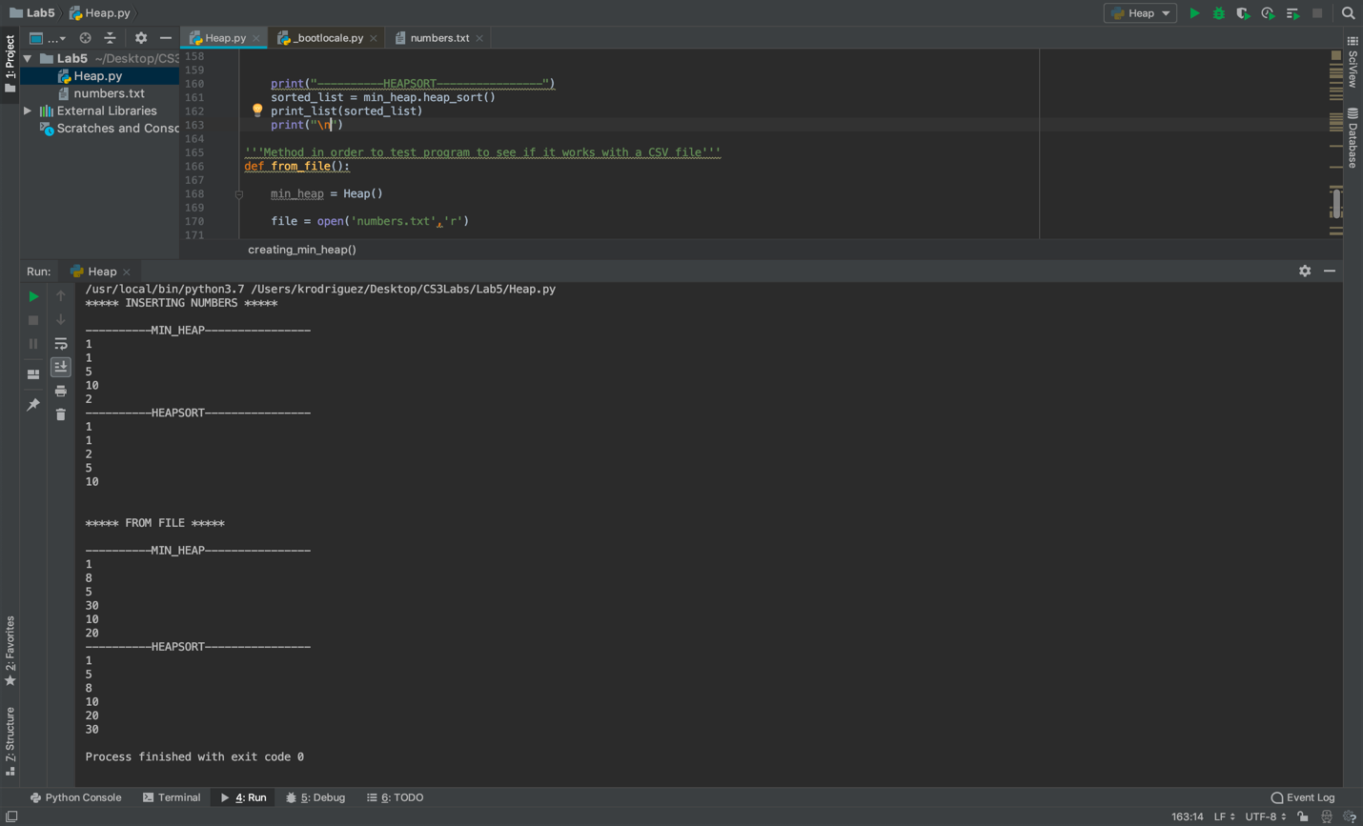

BIG O Notation: Heap Sort's Big O is O(n log n). The advantage that this sorting algorithm has over something like Quick Sort, is that

Heap Sort has a worst case scenario with a running time of O(n log n) comparing to Quick Sort's worst case of O(n^2)

***Conclusion***

This lab was fairly easy since we had covered Heaps before in class, which was from the previous lab. I find it fun to play around with the program to see what special things it could do. I liked this lab a lot.

***Signed Academic Honesty Certification***

I certify that this project is entirely my own work. I wrote, debugged, and tested the code being presented, performed the experiments, and wrote the report. I also certify that I did not share my code or report or provided inappropriate assistance to any student in the class